FOR IMMEDIATE RELEASE - NEWS

Smart PCI-express x16 Bus Extender Reports Power Usage

Simplifies testing and debugging of PCI-express x16, x8, x4, x2 and x1 boards

Orinda CA, May 5, 2007, Furaxa Inc. today announced its PCIeEXT-16 “Smart” PCI-express bus extender board which, when installed in any PCI-express x16 motherboard socket, facilitates easy testing and debug of of PCI-express boards of all data widths (x16, x8, x4, x2 and x1). Controlled impedance, active current sensing on all power supply voltages, and overload reporting, make the PC

Lubricated gold-plated contacts in the top connector on the PCIeEXT-16 bus extender board withstand thousands of insertions, facilitating heavy production testing of PCI-express boards-under-test. Additionally, the labeled bus lines enable the PCIeEXT-16 board to be used in engineering debugging setups. Controlled-impedance on all high-speed lines ensures reliable operation in 2.5Gb/sec lanes, and maximizes the likelihood of reliable operation in next generation 5Gb/sec PCIe slots.

CURRENT MONITORING AND OVERLOAD REPORTING
Three precision milli-ohm-range current sensing shunt resistors, and three instrumentation amplifiers are used to provide a real-time output voltage corresponding to the current being drawn by the board-under-test, on the +3.3V, +12V and +3.3VAUX power supplies. A test point with a 1V/Ampere output is provided for each power supply, for connection to oscilloscopes, multimeters, etc. For example, if a board-under-test is drawing 2.4A and 1.3A respectively, from the +3.3V and +12V power supplies, the PCIeEXT-16's “+3.3 CURR. (1V/A)” and “+12 CURR. (1V/A)” output jacks will provide 2.4 Volt and 1.3 Volt output readings, respectively. If the power on the +12V jack exceeds 2.1 Amperes, a red “12 I>2.1A” LED illuminates, and if the board-under-test is drawing a total current of more than 3.3A on the +3.3V and +3.3VAUX supplies, then the red “+3.3 I>3A” LED illuminates.
The PCIeEXT-16 PCI-express extender is priced at $349 in single-piece quantities, and $299 in quantities of 3 or more.
Further information may be obtained at www.furaxa.com, or by contacting Brendan Illingworth at 925-253-2969 or by email at billingworth@furaxa.com.

Further information on this product, including the user manual can be found at::
http://www.furaxa.com/PCIeBusExtenders.htm

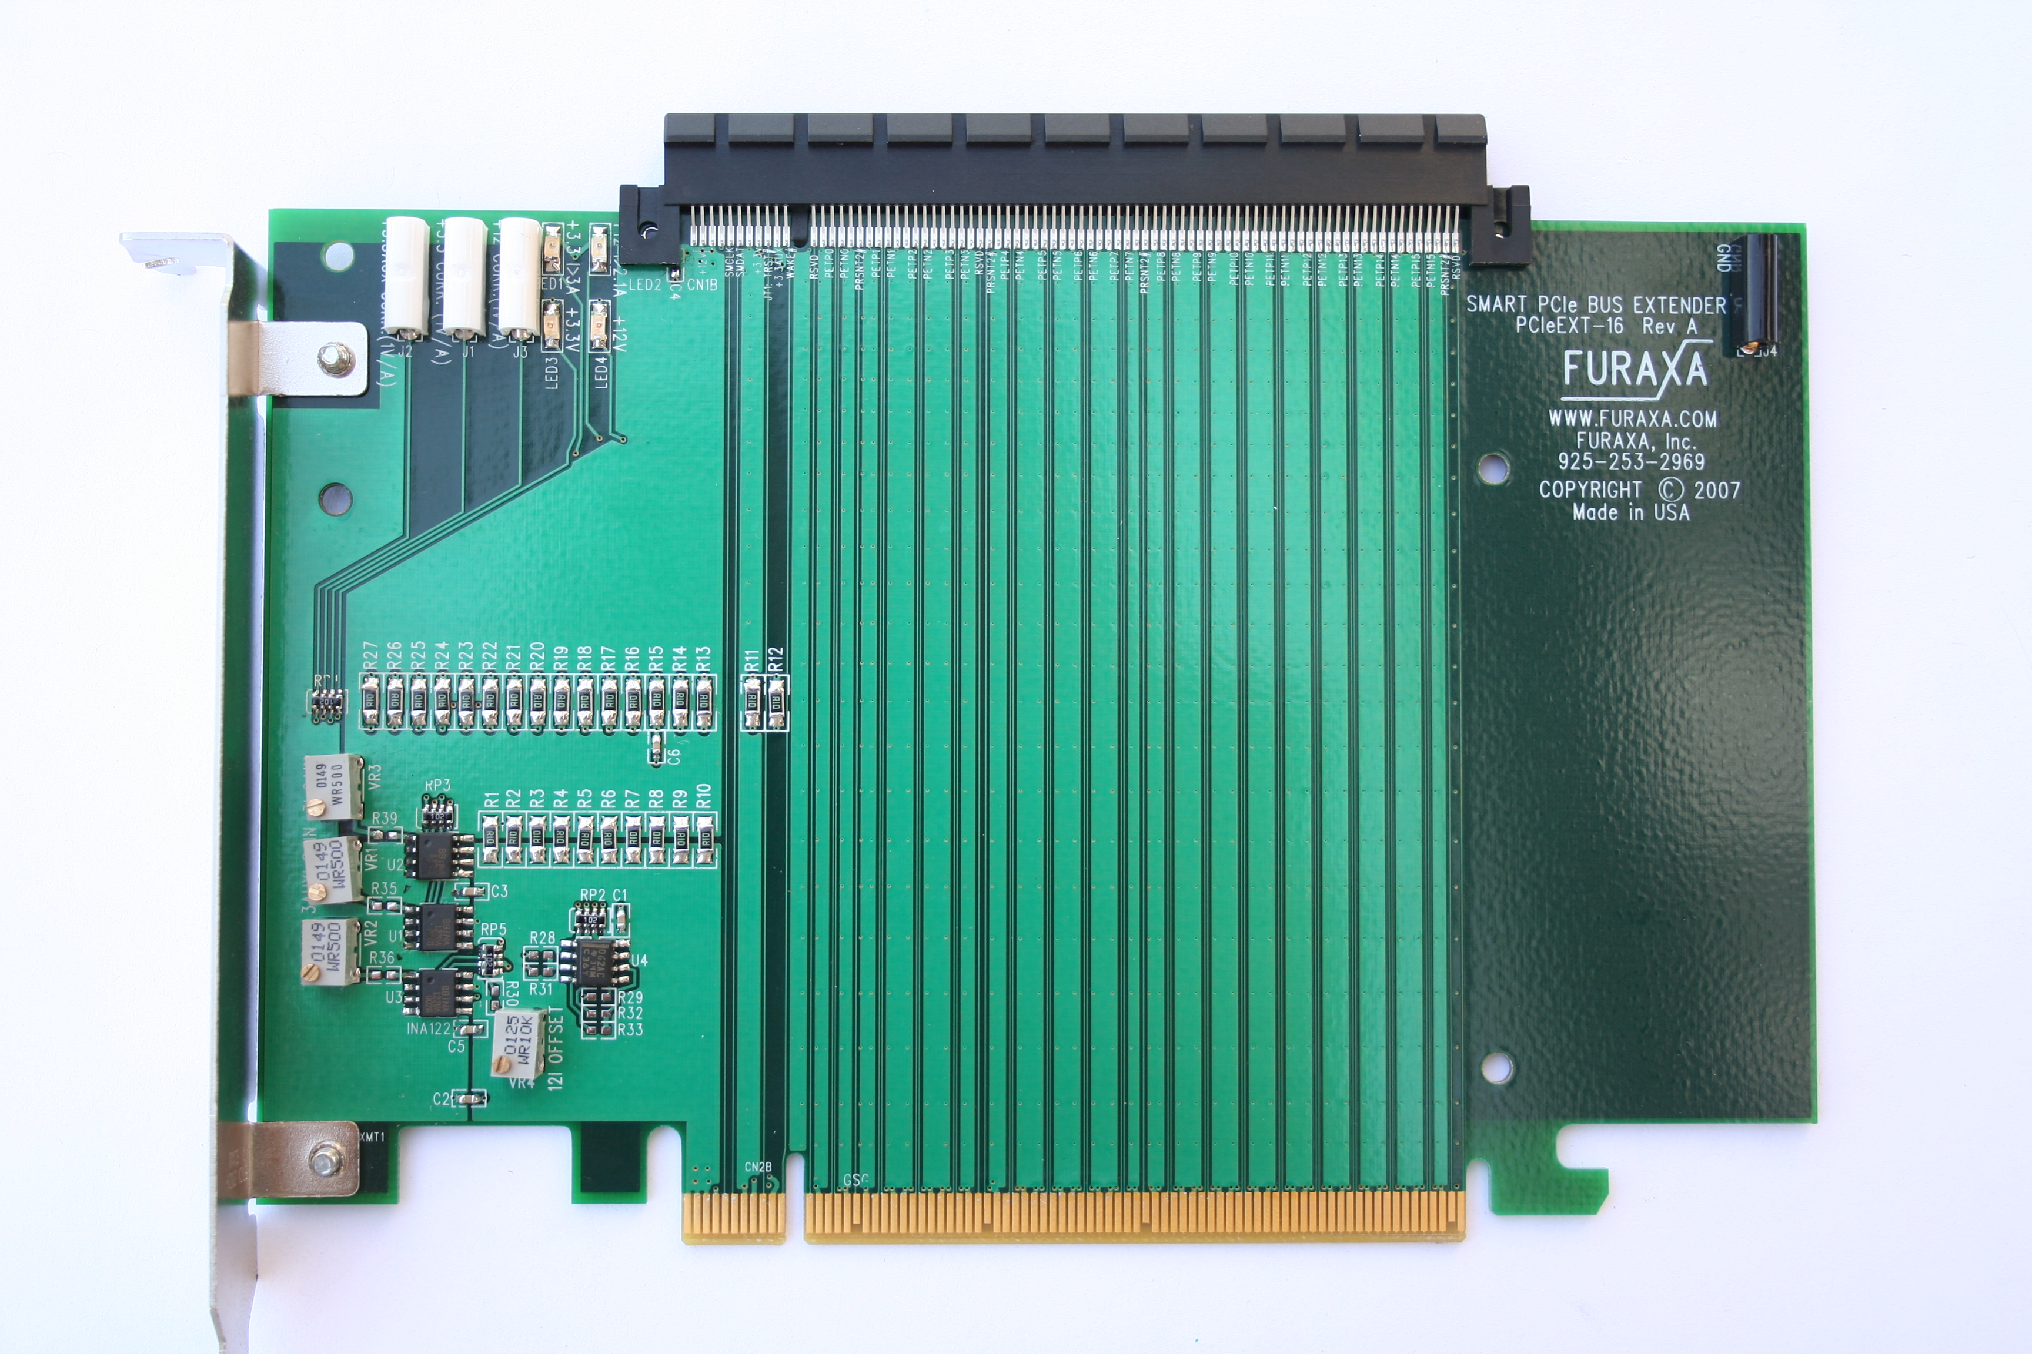
Photograph 1: Furaxa PCIeEXT-16 extender board.

END

Press Contact  Barbara Sacks  bsacks@furaxa.com  925 253 2969  925 253 4894 Fax | Sales Contact  Brendan Illingworth  Furaxa, Inc.  34 Canyon View Dr.  Orinda, CA 94563  sales@furaxa.com  925 253 2969  925 253 4894 Fax  www.furaxa.com  .

