FOR IMMEDIATE RELEASE - NEWS

Microwave Pulser IC Fires 3 Billion Ultra-fast (10-ps) Pulses/second with Dynamic Amplitude and Sub-picosecond Timing Control

Enables high SNR UWB RADAR, direct satellite upconversion, and microwave signal synthesis without the need for expensive microwave oscillators.

Orinda, CA, April 25, 2006, Furaxa Inc. today announced successful demonstration of ICs and IP cores employing a new method of low-cost picosecond pulse generation, enabling direct synthesis of UWB microwave bursts, direct modulation in the entire group of satellite transmission bands and direct microwave/RF frequency synthesis. Furaxa’s FPINPG2-10ps Indium Phosphide pulser ICs generate streams of pulses having widths as short as 10 picoseconds (10ps), repetition rates of up to 3 billion pulses/second and adjustable bipolar amplitudes of up to 300mV, resulting in spectrally pure, dynamically modulated combs of frequencies up to 60 GHz in response to input clocks ranging from 100KHz to 3GHz.

The company believes that this high-repetition rate, modulatable, monolithic pulse generating technology, with sub-picosecond jitter, will form the basis of a number of next-generation RF subsystems used in test and measurement, UWB communications, direct microwave/RF synthesis, medical imaging, RADAR, and other applications with high-fidelity signal synthesis requirements extending up to and beyond 50 GHz.

The spectrally pure harmonics generated by these low-jitter duration/position/amplitude-modulatable pulsers, allows direct synthesis and conversion of wideband satellite and other transmit RF signals in all bands (Ku, Ka, C, etc.) up to 60GHz. Such synthesis and conversion is accomplished without the use of mixers or expensive YIG-Tuned Oscillators, and only requires lower-cost clock sources (with suitably low jitter) in the 1 to 3GHz range. This formerly unattainable combination, in a pulser, of 3GHz pulse repetition rate and bipolar amplitude modulation make pulser-based satellite band up-conversion truly practical, as it allows wide (3GHz) spacing between images, so that conventional filters can easily select the desired frequency image. Furthermore the ability to generate these fewer, more widely spaced, images enables more efficient Tx drive and increased SNR at a given frequency image.

The IC’s novel pulser architecture does not rely on expensive or power-hungry prior microwave pulse generation components such as step recovery diodes (SRDs) or non-linear transmission lines (NLTLs), and is fully monolithic, with a small IC footprint, allowing dense arrays of pulsers to be integrated on a single die, enabling dynamic microwave signal synthesis at very low cost. Based on the Libove-Chacko gate (US Patent 6,433,720), the technology uses a novel stacked-flying-cascode current steering technology to generate brief low-jitter, adjustable pulses that rise and then immediately fall within a few picoseconds in response to single standard ECL or PECL clock edges. Photograph 1 is a time-domain display of pulses approximately 10ps wide (15.4ps when viewed on the 50GHz oscilloscope) 500 ps apart (2 billion/second), and photograph 2 is a spectrum analyzer display showing the comb of frequencies from 1 to 40 GHz produced by a single pulser fed with a 1 GHz input clock. Photograph 3 shows octal sampler and pulser variants of the InP ICs, demonstrating the ability to combine multiple sampler/pulser elements on the same die to generate complex microwave waveforms. The technology can produce either unipolar single-ended pulses, or differential pulses capable of bipolar amplitude modulation.

The technology’s smaller size, lower supply voltage (3V) than other microwave pulse generating technologies, and ability to be powered down seamlessly between pulses, enable its use in very low-power portable applications. For example, a CMOS IP core of this pulser technology is being designed in, as the UWB transmitter, to an RFID tag by Tagent Corporation.

The IC development was funded in part by the Naval Research Laboratory (NRL). Hal Levitt, the NRL sponsor of the research leading to this technology predicts, "Furaxa’s achievements in ultra-fast monolithic pulser technology represent a potential breakthrough in the development of future military electronic warfare (EW) and communications systems that encompass the entire microwave and millimeter RF bands. Undoubtedly, there are applications for this technology that have yet to be envisioned."
The company is seeking to license these IP cores to corporate partners for use in a number of products and applications. Further information may be obtained at www.furaxa.com, or by contacting Steven Chacko at 925-253-2969 or by email at chacko@furaxa.com.

PDF and Word versions of this document and graphics files are located at:
http://www.furaxa.com/new_pages/Documents/pulser_sampler/Pulser_news_release_v10.doc

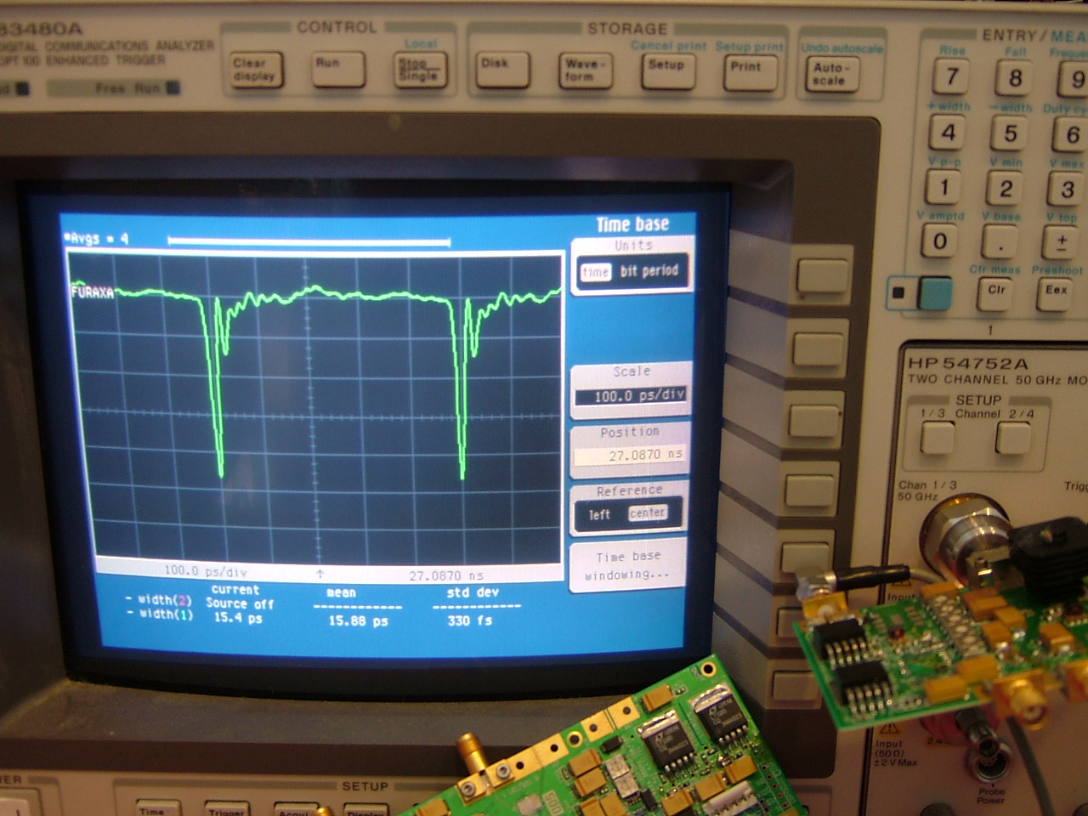
Photograph 1: Time waveform of ultrafast pulses generated at 2 Billion pulses/second

Press Contact  Barbara Sacks  bsacks@furaxa.com  925 253 2969  925 253 4894 Fax | Sales Contact  Furaxa, Inc.  34 Canyon View Dr.  Orinda, CA 94563  Sales@Furaxa.com  925 253 2969  925 253 4894 Fax  www.furaxa.com

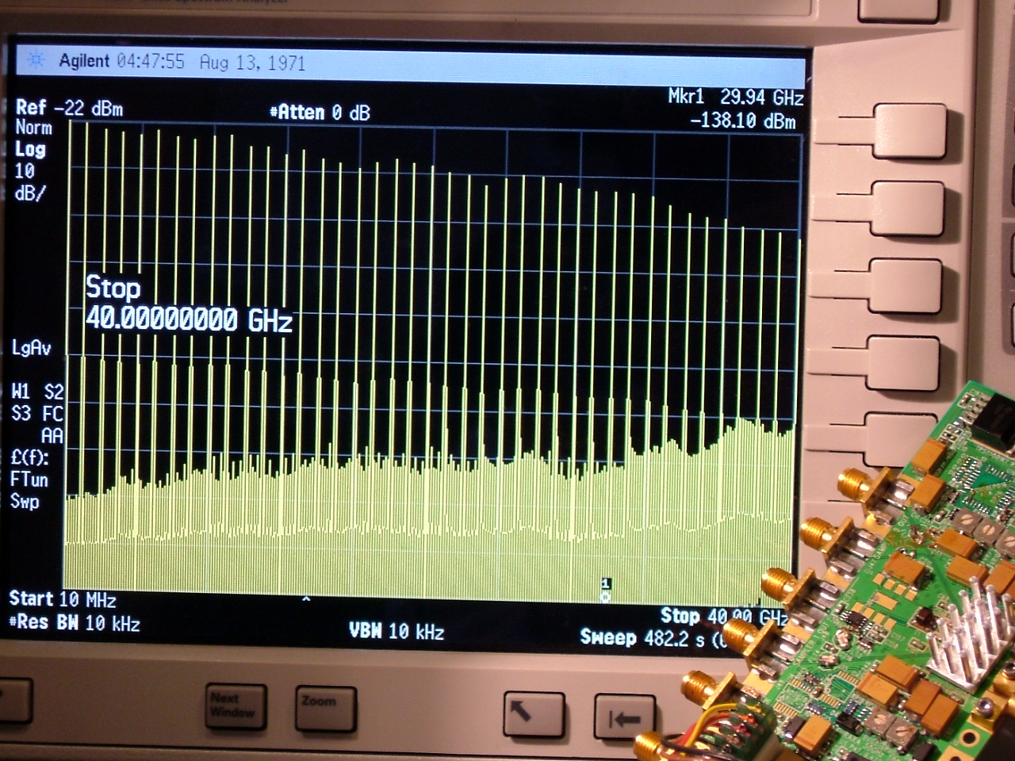
Photograph 2: 40 GHz Frequency Spectrum of ultrafast pulse train generated at 1 Billion pulses/second

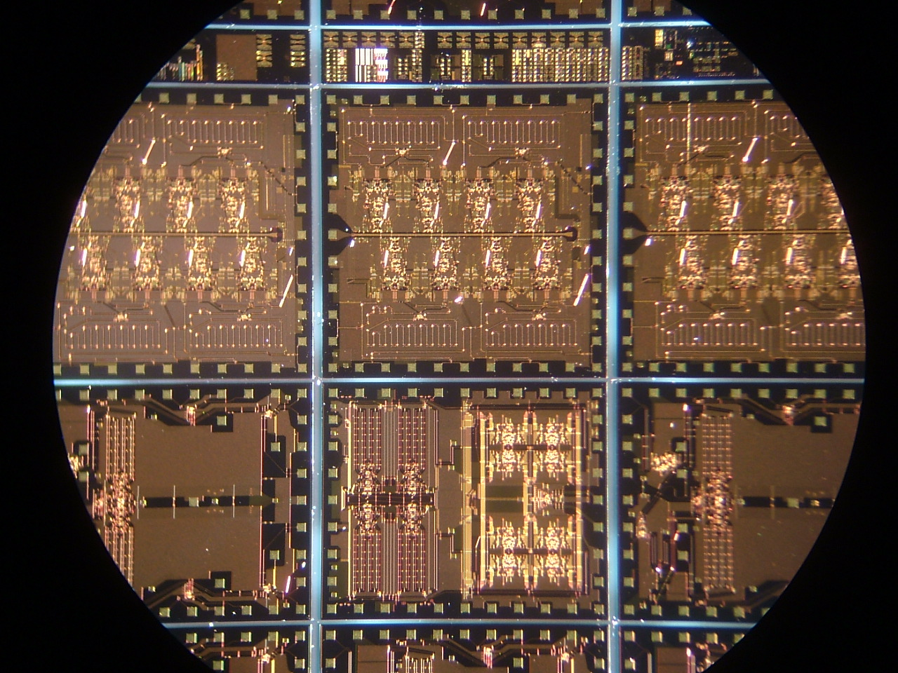
Photograph 3: InP ICs viewed under optical magnification. Octal sampler and pulser variants shown.

